The Hindu April 10, 2021

JRD Tata and the Ethics of Philanthropy’ review: Business and social welfare
N.S. Gundur

JRD Tata introduced an ethical dimension to the corporate world as early as the beginning of the 20th century
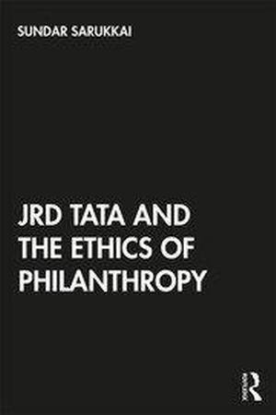
“A business,” American industrialist Henry Ford observed, “that makes nothing, but money is a poor business.” If minting money is an ethical issue in domains such as politics, education, sports and such other fields, it is quite understandable. After all, the end of these fields is not profit-making. But the problem arises when we think that making money is not a virtue in the domain of business which comes into being solely for the sake of profit-making.
Ethical factors, therefore, are more complicated, nuanced and intriguing in the field of business than in any other human activity. They pose challenges not only to businessmen and women, but also to thinkers. It is in this context that Bengaluru-based philosopher Sundar Sarukkai, in his JRD Tata and the Ethics of Philanthropy, takes up the challenge of untangling the problems of ethics in the field of business by analysing the exemplary work of Jehangir Ratanji Dadabhoy Tata. JRD, as Sarukkai’s book shows, introduced an ethical dimension to the corporate world as early as the beginning of the 20th century.
While there are multiple narratives that document the biographical self of JRD and the achievements of the Tatas, Sarukkai has attempted something different — the analysis of JRD’s ideas, especially his understanding of philanthropy. In eight chapters, the author illuminates on philosophical ideas related to the ethics of philanthropy as JRD envisaged and practised it. These chapters are organised around key themes such as trusteeship, the relationship between business and social welfare, the notion of the private and the public, the idea of profit, and social ethics.
The book argues that ‘for JRD, business without philanthropy could not be imagined’. The second chapter, thus, discusses the problems in the field of ‘Ethics of Philanthropy’, thereby preparing the reader for the following chapters which examine how the question of philanthropy was an essential part of what it meant for JRD to be an entrepreneur and a leader.
The book is written with the conviction that in JRD’s philosophy there is ‘a possibility of finding newer paradigms for social development in today’s world’. JRD’s concept of trusteeship, among others, serves Sarukkai to demonstrate this conviction. Accordingly, the third chapter ‘Trusteeship’ shows how JRD, influenced by Gandhi, viewed his wealth only as a trustee on behalf of others. The remaining chapters subsequently illustrate JRD’s understanding of the relation between business and philanthropy.
Present-day critique
JRD grew up as India was growing into a nation, and the connection between JRD and the making of our nation could have made a fine historical narrative. But Sarukkai keeps an eye on the present by providing a critique of today’s Tata institutions and philanthropic initiatives. Further, he finds fault with philanthropic organisations related to Infosys and Mahindra for supporting educational/ research programmes in the U.K. and the U.S. universities, hardly caring for Indian universities.
Meticulous research material collected in the JRD archives at Pune and also the Tata archives at Jamshedpur has gone into the making of this book. Sarukkai is at his best in clarifying the philosophical ideas with utmost clarity and confidence, but the explanation of concepts dominates the narrative, at times ignoring the protagonist. However, this does not undermine the value of this book. It remains useful for those interested in business ethics, philanthropy, and JRD. Above all, Sarukkai’s prose rarely tires the reader.
JRD Tata and the Ethics of Philanthropy; Sundar Sarukkai, Routledge, 695.
The writer is Chairman, Department of English Studies, Davangere University, Karnataka.

